Name: Sindhu Gaddam
Student ID: 24071473
College Name: University Of Hertfordshire
GitHub Link: https://github.com/Sindhu809/Time-Series-Analysis--24071473
1.Introduction:
In contemporary power systems, accurate forecasting of electricity demand is crucial. Forecasts are used by energy providers and grid operators to make sure that power generation and consumption are balanced while preserving system efficiency and dependability. Inaccurate demand projections may result in higher operational expenses, ineffective resource distribution, and possible instability in the electrical grid. The analysis focuses on electricity demand in Germany between January 2015 and September 2020. The dataset contains hourly electricity load measurements obtained from the Open Power System Data platform and provides an opportunity to examine both short-term and long-term demand patterns.
The project begins with data preparation and exploratory data analysis to understand the characteristics of the time series. Stationarity tests and seasonal decomposition are then applied to identify underlying patterns within the data. Several benchmark forecasting methods are implemented to establish a baseline level of performance. These benchmark methods include the Mean Forecast, Naive Forecast, Seasonal Naive Forecast, and Drift Forecast. Later, more sophisticated forecasting techniques are created and assessed. The weekly electricity demand series' temporal dependencies and seasonal characteristics are captured using a Seasonal Autoregressive Integrated Moving Average (SARIMA) model. Berlin temperature data is used as an explanatory variable in a Seasonal Autoregressive Integrated Moving Average with Exogenous Variables (SARIMAX) model to examine the impact of external variables.
2. Data:
2.1 Describing the dataset:
The Open Power System Data (OPSD) platform provided the dataset used in this project. Electricity-related variables, such as electricity demand, electricity generation, and electricity costs, are included in the original dataset for several European nations. The collection has over 50,000 time-stamped records and is made up of hourly observations gathered over a number of years. Only the German electrical load variable, DE_load_actual_entsoe_transparency, was chosen for investigation because the project's main goal is to forecast German power demand. This variable, which is expressed in megawatts (MW), reflects Germany's actual electricity demand.
2.2. Preparation of the data:
The Pandas library was initially used to import the dataset into Python. Time-series operations were made possible by converting the timestamp column into a datetime format and setting it as the dataset's index. To make the study easier to comprehend, the German electricity load column was subsequently modified to load, a more straightforward variable to find any missing values, the data was first examined. The filtered German power demand series had no missing observations, according to the results.

3. Analysis of Stationarity:
A key premise of many time-series forecasting methods is stationarity. Statistical characteristics of a stationary series, including variance and mean, are comparatively consistent over time. The weekly electricity demand series was subjected to the Kwiatkowski-Phillips-Schmidt-Shin (KPSS) test and the Augmented Dickey-Fuller (ADF) test to determine stationarity. Because the two approaches employ distinct null hypotheses, using both tests yields a more trustworthy evaluation. The ADF test assesses the null hypothesis that the series is non-stationary because it has a unit root. The test yielded a p-value of 0.00118 and an ADF statistic of -4.047. Next, the KPSS test was used as an additional assessment. Figure 1 & 2 below shows the ACF &PACF plots.
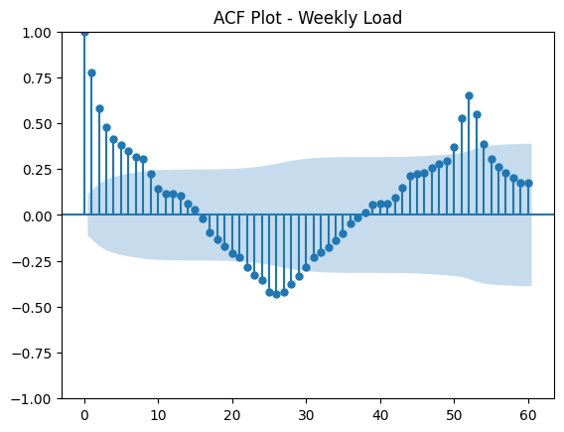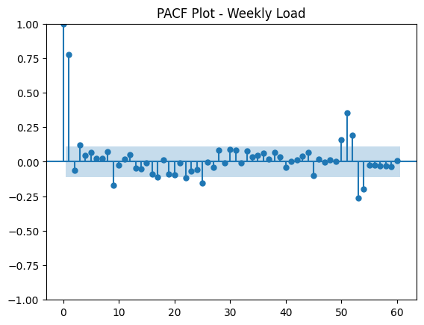
4. Forecasting Models:
Model | RMSE | MAE | MAPE
Mean | 4397.30 | 3788.83 | 6.97
Naïve | 4459.11 | 3793.20 | 6.79
Seasonal Naïve | 3006.76 | 2318.52 | 4.41
Drift | 5117.96 | 4339.89 | 8.05
A training set and a test set were created using the weekly electricity demand data. The remaining observations were utilised to train the model, and the last 104 weeks of data, or almost two years, were set aside for testing. Four benchmark forecasting techniques were assessed as Mean Forecast, Naïve Forecast, Seasonal Naïve Forecast, Drift Forecast
The Mean Forecast uses the average of all observations made during the training period to forecast future values. The final observed value from the training set is used by the Naive Forecast to forecast all subsequent periods. The Drift Forecast projects the past trend into the future, whereas the Seasonal Naive Forecast replicates measurements from the comparable week in the prior year. With an RMSE of 3006.76 and a MAPE of 4.41%, the Seasonal Naive model had the lowest forecasting error. This finding suggests that there is a significant annual seasonal trend in the demand for power in Germany. The Seasonal Naive model was chosen as the main standard by which all later forecasting models were evaluated in light of these findings.
5. The SARIMA Model:
To account for the temporal dependency and seasonal behaviour seen in the weekly electricity demand series, a Seasonal Autoregressive Integrated Moving Average (SARIMA) model was created. The ability of SARIMA models to describe trend, autocorrelation, and seasonal trends in a single framework makes them popular for time-series forecasting. Using the parameter ranges given in the assignment, a grid search was carried out to find appropriate model parameters. The moving average parameter (q) was adjusted between 0 and 6, the autoregressive parameter (p) between 0 and 6, and the differencing parameter (d) between 0 and 2. The weekly data's annual seasonality was represented by a seasonal period of 52 weeks. The Akaike Information Criterion (AIC), where lower values denote a better balance between model fit and complexity, was the original basis for model selection. SARIMA(2,2,6)(1,1,1,52) was found to have the lowest AIC value in the grid search.
Model | RMSE | MAE | MAPE
Seasonal Naive | 3006.76 | 2318.52 | 4.41
Best AIC SARIMA | 9470.26 | 8108.35 | 15.24
Final SARIMA | 2788.72 | 2149.28 | 4.09
However, this model's forecasting ability was comparatively subpar when tested on the hold-out test set. Despite having a good fit to the training set, the model struggled to generalise to new observations. This implies that the historical data may have been overfitted by the model. The weekly series was already stable based on both the ADF and KPSS tests, according to the previous stationarity analysis. As a result, a number of more straightforward SARIMA models without non-seasonal differencing (d = 0) were assessed. SARIMA(3,0,2)(1,1,1,52) outperformed the other models in terms of forecasting. The SARIMA residuals usually oscillate around zero, showing that the primary seasonal structure was recorded. Remaining spikes and residual autocorrelation, however, show that the model continues to overlook anomalous demand fluctuations.
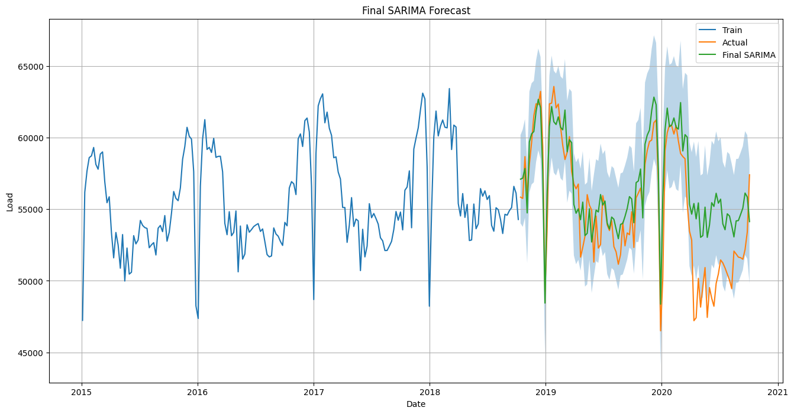
Figure3: Final SARIMA Forecast
6.Temperature-Based SARIMAX Model:
Electricity usage is frequently impacted by outside variables like weather, even if SARIMA models only take previous electricity demand into account. A Seasonal Autoregressive Integrated Moving Average with Exogenous Variables (SARIMAX) model was created to examine whether weather data could enhance forecasting ability.
The SARIMAX model incorporated temperature as an exogenous input while maintaining the same structure as the final SARIMA model. This method made it possible for the model to account for both the impact of weather and the temporal dynamics of electricity demand. There is an inverse relationship between temperature and electricity demand, as indicated by the calculated temperature coefficient being negative. Practically speaking, lower electricity use was typically linked to greater temperatures. The RMSE and MAPE for the SARIMAX model were 2847.08 and 4.12%, respectively. This performance was marginally worse than the final SARIMA model, although being superior to the Seasonal Naive benchmark. As a result, adding temperature to this dataset did not increase forecasting accuracy.
Instead of being an operational prediction, the SARIMAX temperature forecast is conditional or explanatory. This is a result of the test period's recorded temperature readings being utilised as inputs. Future temperature data would have to be obtained from a weather forecast in a real operational situation, which would add to the uncertainty. The model would become a true operational forecast if weather forecast values were substituted for observed temperatures.
Model | RMSE | MAE | MAPE
Seasonal Naive | 3006.76 | 2318.52 | 4.41
SARIMA | 2788.72 | 2149.28 | 4.09
SARIMAX | 2847.08 | 2155.22 | 4.12
SARIMAX + HOLIDAYS | 2670.12 | 1955.7 | 3.75
Because observed test-period temperature was used, the SARIMAX forecast should be understood as a conditional or explanatory forecast. Observed future temperatures shouldn't be regarded as information accessible at the forecast origin since a true operational forecast would need to be derived from weather forecasts.
Overall, the findings offer helpful explanatory information and imply a relationship between temperature and electricity demand. However, when compared to the SARIMA model, the added temperature variable did not result in a discernible increase in forecasting accuracy within the parameters of this investigation.
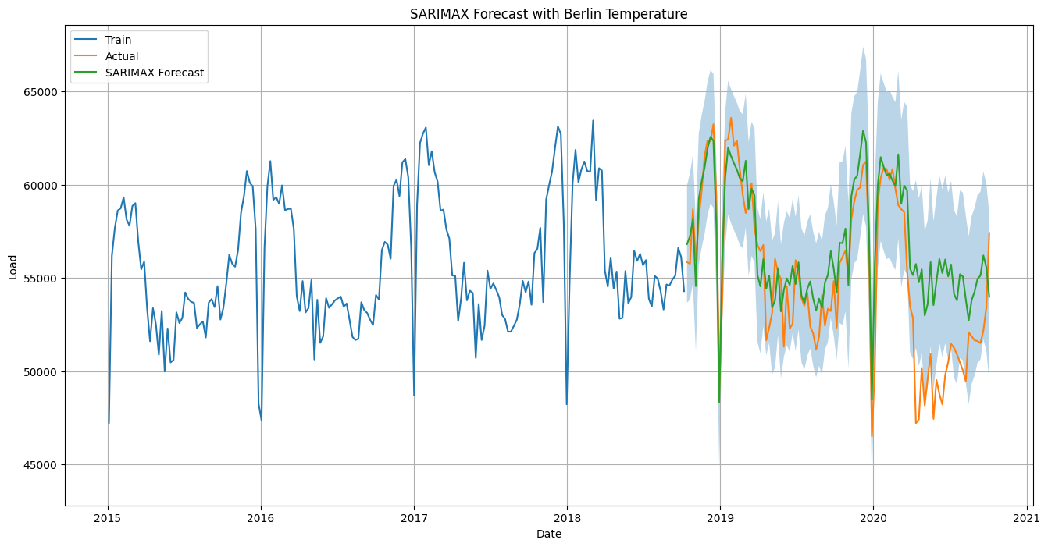 Figure4: shows the weekly berlin temperature and SARIMAX forecast
7.Random Forest (Regression Model Based on Feature):
A Random Forest regression model was used to study a machine learning approach in addition to statistical forecasting techniques. An ensemble learning system called Random Forest aggregates the predictions from several decision trees. In contrast to SARIMA models, Random Forest can capture intricate non-linear correlations in the data and does not require stationarity assumptions.
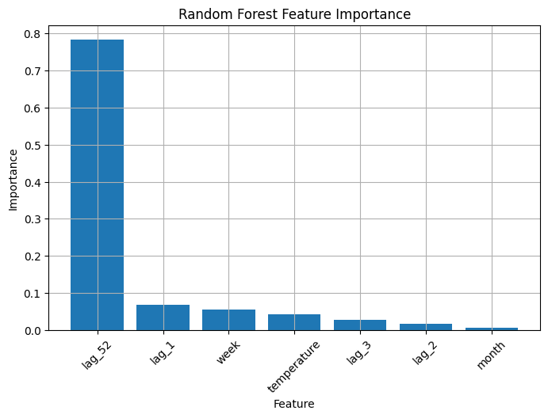
The final set of features comprised: (Figure5):
- Average temperature per week
- One-week lag in load
- A two-week lag in load
- Three weeks' delay in loading
- 52 weeks of load lag
- The week of the year
- Month
The Random Forest model's RMSE was 2475.07, its MAE was 1789.35, and its MAPE was 3.44%. These outcomes show a discernible improvement over the statistical forecasting models as well as the Seasonal Naive benchmark
Model | RMSE | MAE | MAPE
Seasonal Naive | 3006.76 | 2318.52 | 4.41
SARIMA | 2788.72 | 2149.28 | 4.09
SARIMAX | 2847.08 | 2155.22 | 4.12
Random Forest | 2475.07 | 1789.35 | 3.44
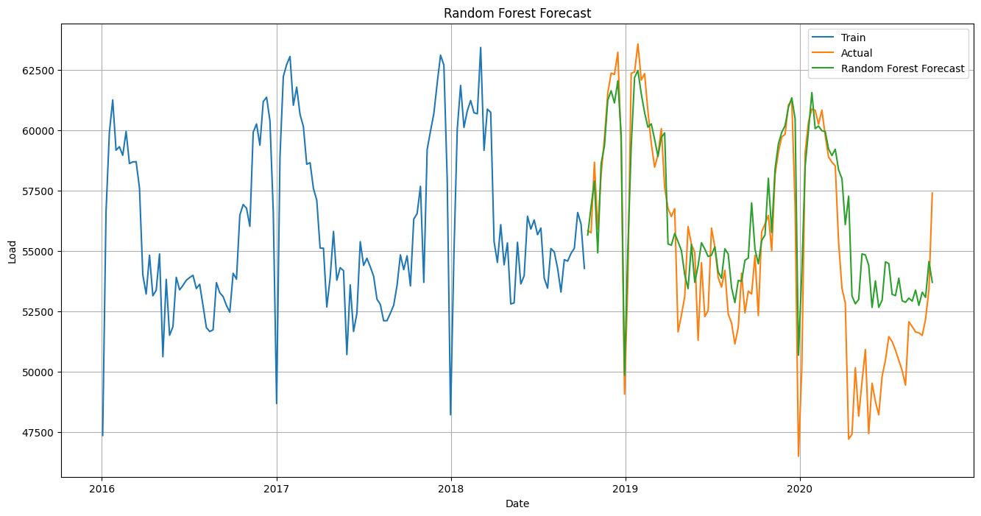
Figure 6: Shows the Random Forest Forecast vs Actual Demand
8. Model of Long Short-Term Memory (LSTM):
Because deep learning models can automatically identify intricate patterns from vast amounts of historical data, they have grown in popularity for forecasting electricity consumption. This experiment used hourly observations to model power demand using a Long Short-Term Memory (LSTM) neural network. The LSTM model was trained directly on the initial hourly electricity demand series, in contrast to the earlier models that were trained on weekly aggregated data.
The model yielded an MAE of 893.31, a MAPE of 1.66%, and an RMSE of 1166.40. Compared to the benchmark models, Random Forest, SARIMA, and SARIMAX, these values were significantly lower. The LSTM model's improved performance can be explained by its capacity to immediately learn intricate temporal correlations from the hourly data. In contrast to conventional statistical models, the LSTM can identify non-linear trends in the behaviour of electricity consumption and does not rely on stationarity assumptions.
Random Forest is better balanced for operational application because it is simpler to maintain and interpret, even if LSTM achieved the lowest error. Although SARIMA's accuracy was lower than that of the machine learning models, it is nevertheless helpful because it offers uncertainty intervals.
Overall, the findings imply that, given enough historical data, deep learning techniques can significantly increase forecasting accuracy. The LSTM model has the best forecasting accuracy of all the models assessed for this assignment.
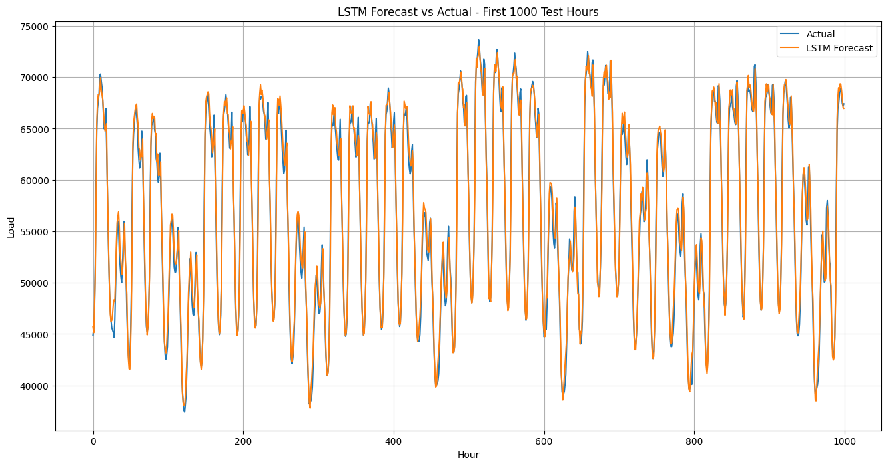
Figure 7 shows LSTM Forecast vs Actual
9. Model Evaluation and discussion:
With an RMSE of 3006.76, the Seasonal Naive model offered a solid baseline. This criterion was exceeded by both SARIMA and SARIMAX, proving the usefulness of statistical time-series modelling. The RMSE of the final SARIMA model was 2788.72, whereas the RMSE of the SARIMAX model was 2847.08. With an RMSE of 1166.40 and a MAPE of 1.66%, the LSTM model performed the best overall. The model significantly outperformed all other methods taken into consideration in this project and was able to immediately understand intricate temporal patterns from the hourly electricity demand data. The LSTM model is the least interpretable and most computationally expensive model, despite its greater accuracy. SARIMA, on the other hand, is appealing for operational forecasting settings where explainability is crucial since it offers more transparency and simpler interpretation. Random Forest strikes a compromise between implementation complexity and prediction accuracy.
Model | RMSE | MAE | MAPE
Seasonal Naive | 3006.76 | 2318.52 | 4.41
SARIMA | 2788.72 | 2149.28 | 4.09
SARIMAX | 2847.08 | 2155.22 | 4.12
SARIMAX+ HOLIDAYS | 2670.12 | 1955.78 | 3.75
Random Forest | 2475.07 | 1789.35 | 3.44
LSTM | 1166.40 | 893.31 | 1.66

10.Questions for Discussion:
10.1. Compare all models against the seasonal naive benchmark. Which models, if any, provide a meaningful improvement?
The best benchmark was the Seasonal Naive model, which had an RMSE of 3006.76 and a MAPE of 4.41%. With RMSE 2788.72 and MAPE 4.09%, SARIMA outperformed this. Though marginally worse than SARIMA, SARIMAX was likewise superior to Seasonal Naive. While LSTM had the lowest total error, Random Forest outperformed the statistical models.
10.2. Explain how you avoided data leakage when creating temperature lag features?
When developing lag and rolling features, only historical data was used to prevent data leaking. To exclude the target week from the input features, load lags, temperature lags, and rolling averages were adjusted.
10.3. For the SARIMAX model, justify the chosen differencing orders and seasonal period?
Because the data were weekly and demonstrated annual seasonality, the seasonal period was set at 52. Since the weekly series was already stationary according to ADF and KPSS tests, non-seasonal differencing was not included in the final SARIMA model. Rather than depending just on AIC, forecast accuracy was also considered.
10.4. Evaluate whether temperature and holiday covariates improve forecast accuracy. Are these covariates known at the forecast origin?
Because the coefficient was negative, indicating that higher temperatures were associated with lower electricity demand, temperature had explanatory significance. Nevertheless, SARIMAX with temperature did not outperform SARIMA. Because holidays are known ahead of time and can be employed safely at the forecast origin, holiday covariates were also examined The SARIMAX model was enhanced by the addition of holiday covariates. While SARIMAX with temperature and holidays increased to RMSE 2670.12 and MAPE 3.75%, SARIMAX with temperature only attained RMSE 2847.08 and MAPE 4.12%. Holidays are safe to use at the forecast origin since they are known ahead of time. Unless weather forecasts are available, the forecast origin does not know the observed future temperature.
10.5.Compare the interpretability and complexity of SARIMAX, feature-based, and neural network models?
SARIMA offers confidence intervals and is simpler to understand. Random Forest provides feature importance values and is capable of capturing non-linear relationships. Although LSTM yielded the highest accuracy, it requires more computation and tuning and is more difficult to understand.
10.6.Recommend one model for operational use and justify your choice using accuracy, uncertainty, interpretability, and maintenance considerations?
Because Random Forest increased accuracy while remaining simpler to understand than LSTM, it is suggested as the best-balanced model. LSTM is the best option if accuracy is the only factor that matters in terms of computer power.
10. Conclusion:
This research used data from 2015 to 2020 to examine several forecasting techniques for German power demand. Machine learning approaches, deep learning models, statistical time-series models, and benchmark forecasting methods were all included in the investigation. The power demand series showed distinct seasonal patterns in exploratory analysis, and stationarity testing verified that the weekly data were appropriate for time-series modelling.
The SARIMA model showed the value of statistical forecasting techniques for predicting power consumption and outperformed the benchmark findings. The SARIMAX model's incorporation of temperature did not increase forecasting accuracy, despite the fact that temperature was found to be connected to electricity consumption. By utilising artificial features and non-linear correlations in the data, the Random Forest model outperformed the statistical models. However, out of all the models taken into consideration, the LSTM model provided the lowest RMSE, MAE, and MAPE values and had the highest forecasting accuracy.
The LSTM model is advised when forecasting accuracy is the main goal, according to the study's findings. However, because they are easier to understand and need less computing power, SARIMA and Random Forest continue to be appealing options.
Future research should look into adding more explanatory factors including holidays, economic indicators, and more precise meteorological data. Additional hyperparameter optimisation and the assessment of different deep learning architectures may also lead to further gains.
11.Citations:
- Access Power System Information. (2020). bundle of time series data
https://data.open-power-system-data.org/time_series/.

- Open-Meteo (2026). documentation for the Historical Weather API.
https://open-meteo.com/en/docs/historical-weather-api.

- Athanasopoulos, G., and R.J. Hyndman (2021). Forecasting: Fundamentals and Application. Third edition. accessible at: https://otexts.com/fpp3/.

- Schmidhuber, J., and Hochreiter, S. (1997). extended short-term memory. Neural Computation, 9(8), 1735-1780.https://direct.mit.edu/neco/article/9/8/1735/6109/Long-Short-Term-Memory.
- Witten, D., Hastie, T., Tibshirani, R., James, G., and Taylor, J. (2023). An Overview of Statistical Learning using Python Applications. Springer. https://www.statlearning.com/

